Grade 7 Accelerated · Unit 3 · Lessons 6–7  Evaluating and Equivalent Expressions  Question Bank - Additional 3.06 ANSWER KEY | Name  Date  Period

Show your work. Circle your final answer.
For questions 1 through 5, apply the laws of exponents to evaluate. Show your steps.
1. 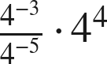


2. 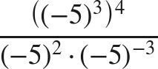
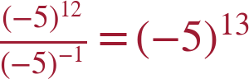 (= −1,220,703,125)

3. 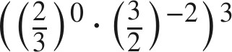
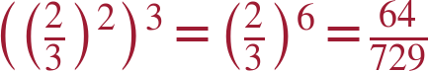

4. 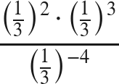
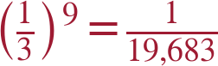

5. 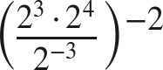
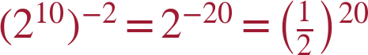

Evaluate each expression in questions 6 through 9. Show all the steps.
6. 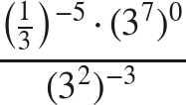
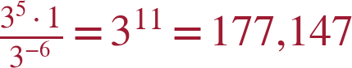

7. 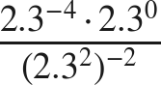
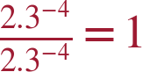

8. 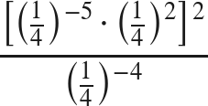
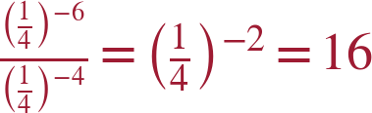

9. 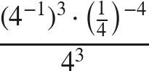
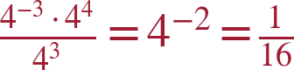

Common bases.
10. Write each expression as a single power with the base given.
a. 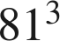 with base 3

b.  with base 2

c.  with base 4

64 = 4³.
d. 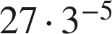 with base 3
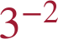

11. Paul says 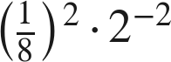 and 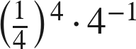 are equivalent because both can be written as .
a. Write the first expression as a single power of 2. Show your work.

b. Write the second expression as a single power of 2. Show your work.

c. Is Paul correct?
No — only the first is ; the second is .

12. Which expression is equivalent to 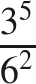 ?
○ A. 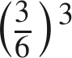
● B. 
○ C. 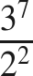
○ D. 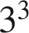
B
6² = 3² · 2², so 3⁵/(3² · 2²) = 3³/2².

13. Find the value of that makes each statement true.
a. 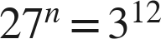
n = 4
b. 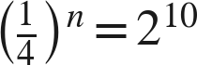
n = −5

